# CSS Layout - Flexbox – Exercise

Problems for exercises and homework for the ["HTML and CSS" course @ SoftUni](https://softuni.bg/courses/html-and-css).

# Topics Covered

[Flexbox](https://developer.mozilla.org/en-US/docs/Web/CSS/CSS_flexible_box_layout) is a one-dimensional layout method for arranging items in rows or columns. Items *flex* (expand) to fill additional space or shrink to fit into smaller spaces. This article explains all the fundamentals.

# Resources

* **Flexbox MDN**
  + <https://developer.mozilla.org/en-US/docs/Learn/CSS/CSS_layout/Flexbox>
* **A Complete Guide to Flexbox**
  + <https://css-tricks.com/snippets/css/a-guide-to-flexbox/>
* **An Interactive Guide to Flexbox**
  + <https://www.joshwcomeau.com/css/interactive-guide-to-flexbox/>
* **Flexbox cheat sheet**
  + <https://codepen.io/kdankov/pen/QWoVyZJ>

## Layout – 3 columns

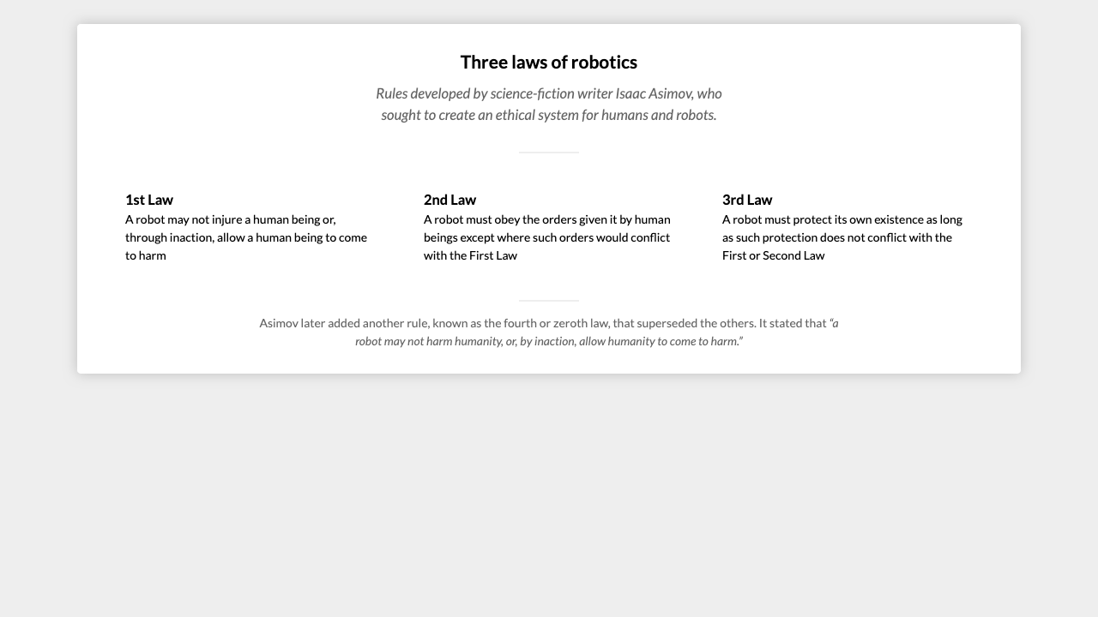

*For full screenshot check the screenshot.png file in the folder for the task*

**Objective:**

Create a webpage that looks like the screenshot above.

**Requirements:**

1. **File Setup**:
   * Create an HTML document named **three-columns.html**
   * Create a CSS file named **three-columns.css**

## Flex order

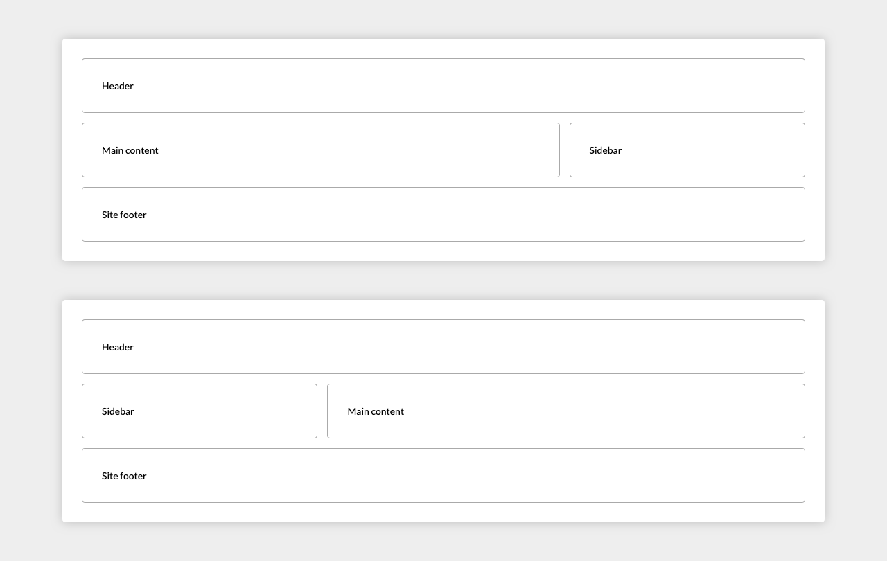

*For full screenshot check the screenshot.png file in the folder for the task*

**Objective:**

Create a webpage that looks like the screenshot above.

**Requirements:**

1. **File Setup**:
   * Create an HTML document named **flex-order.html**
   * Create a CSS file named **flex-order.css**

## Calendar

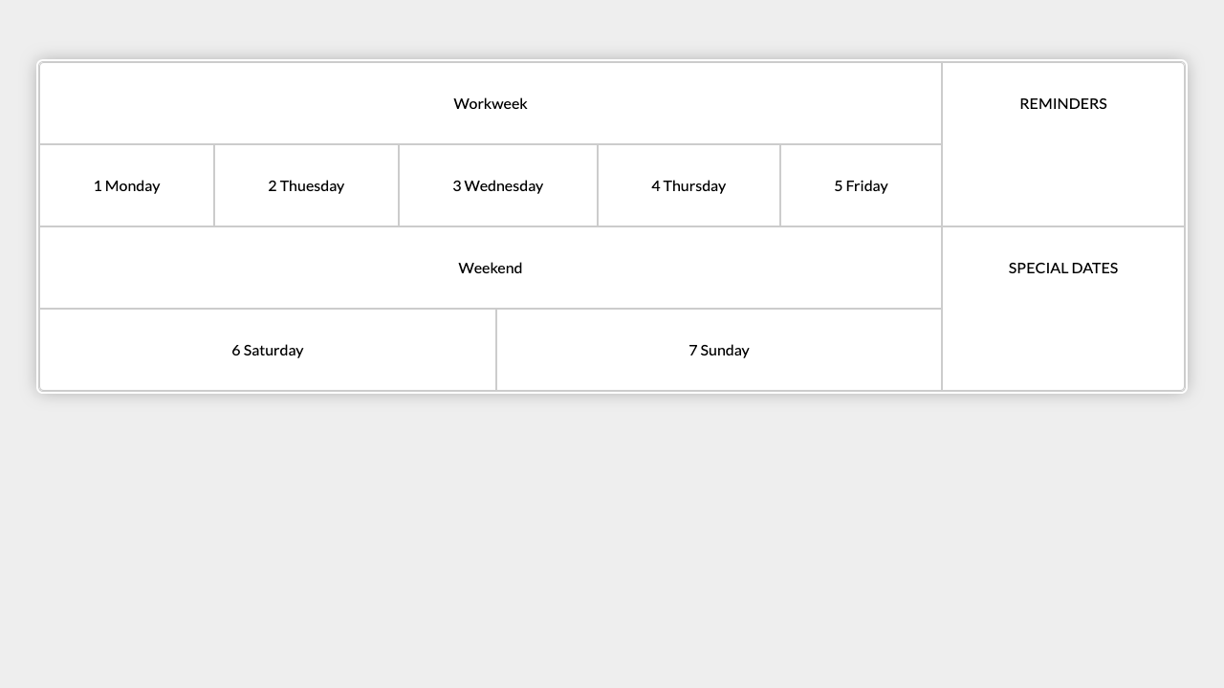

*For full screenshot check the screenshot.png file in the folder for the task*

**Objective:**

Create a webpage that looks like the screenshot above.

**Requirements:**

1. **File Setup**:
   * Create an HTML document named **calendar.html**
   * Create a CSS file named **calendar.css**

## Main Navigation

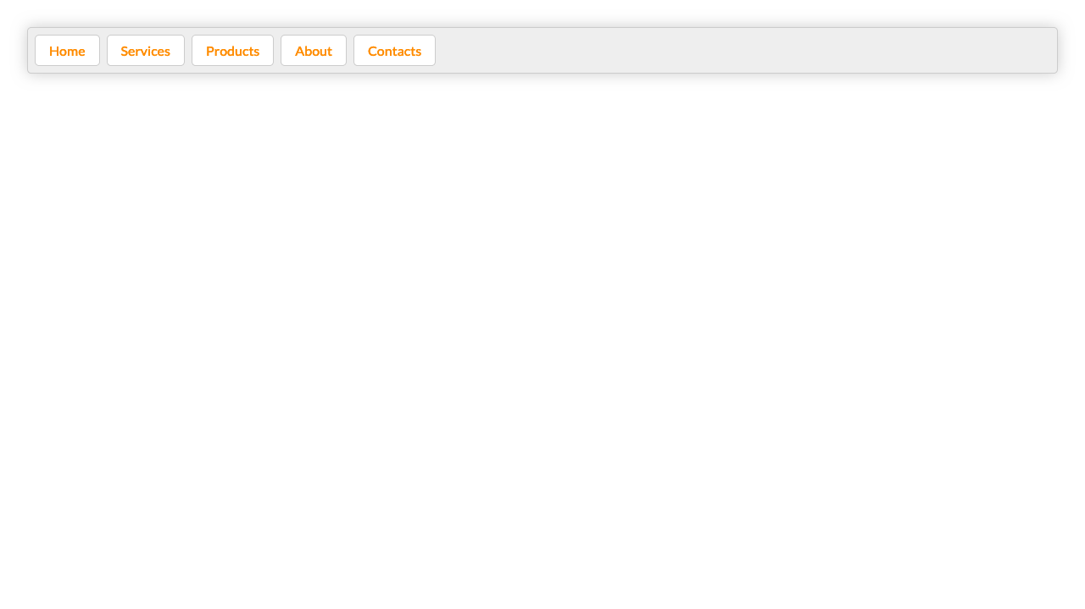

*For full screenshot check the screenshot.png file in the folder for the task*

**Objective:**

Create a webpage that looks like the screenshot above.

**Requirements:**

1. **File Setup**:
   * Create an HTML document named **main-navigation.html**
   * Create a CSS file named **main-navigation.css**
2. **Photo Gallery**

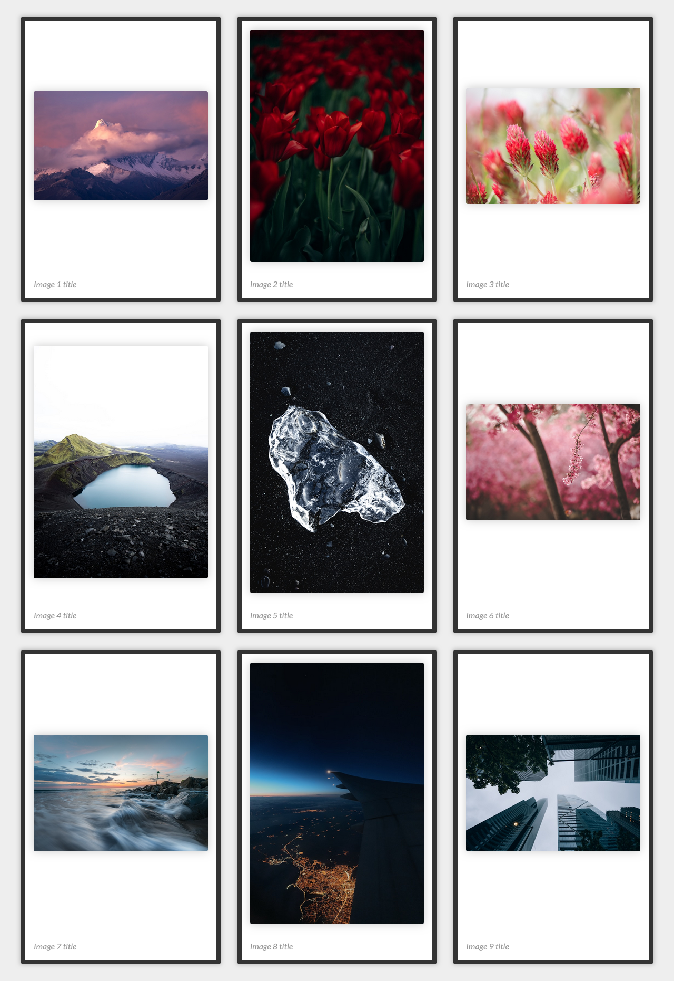

*For full screenshot check the screenshot.png file in the folder for the task*

**Objective:**

Create a webpage that looks like the screenshot above.

**Requirements:**

1. **File Setup**:
   * Create an HTML document named **photo-gallery.html**
   * Create a CSS file named **photo-gallery.css**
2. **Fancy Quotes**

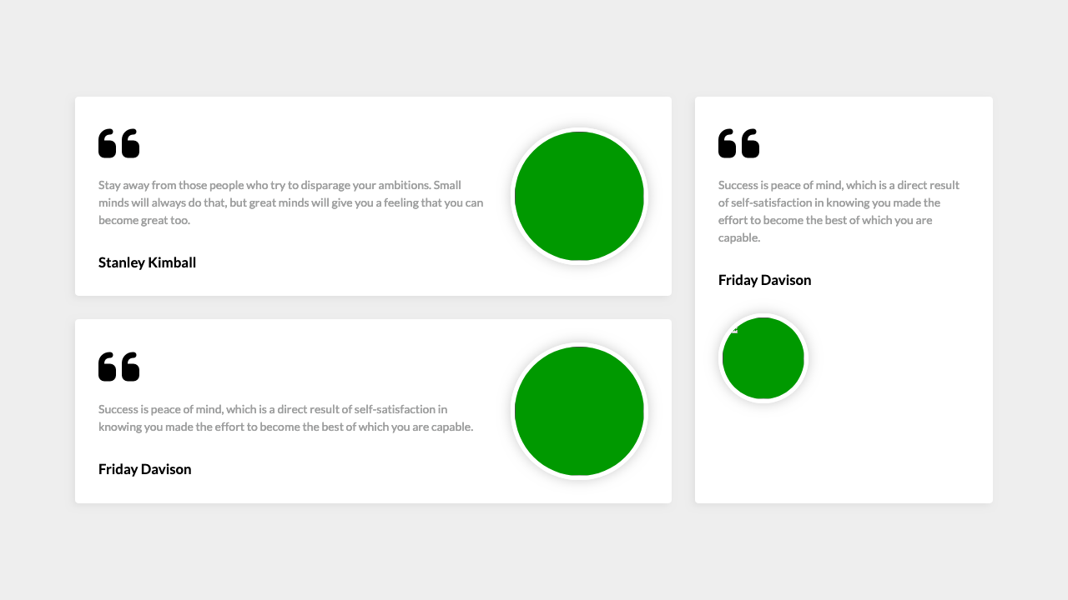

*For full screenshot check the screenshot.png file in the folder for the task*

**Objective:**

Create a webpage that looks like the screenshot above.

**Requirements:**

1. **File Setup**:
   * Create an HTML document named **fancy-quotes.html**
   * Create a CSS file named **fancy-quotes.css**
2. **Expandable Tree view**

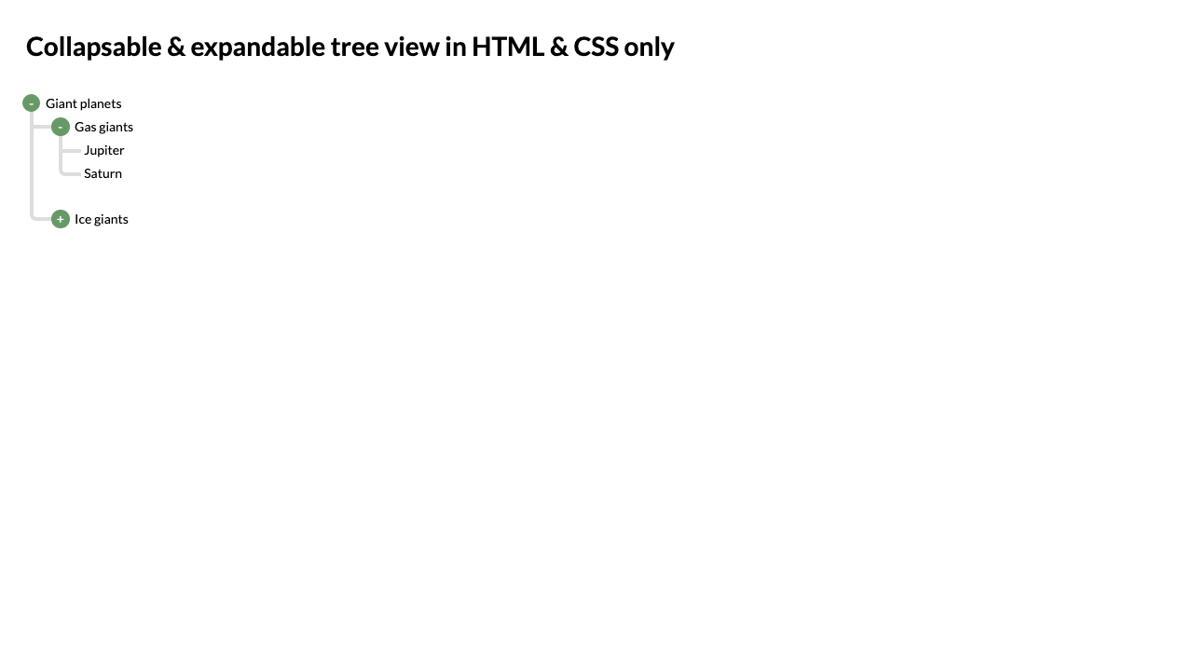

*For full screenshot check the screenshot.png file in the folder for the task*

**Objective:**

Create a webpage that looks like the screenshot above.

**Requirements:**

1. **File Setup**:
   * Create an HTML document named **expandable-tree-view.html**
   * Create a CSS file named **expandable-tree-view.css**
2. **Keyboard**

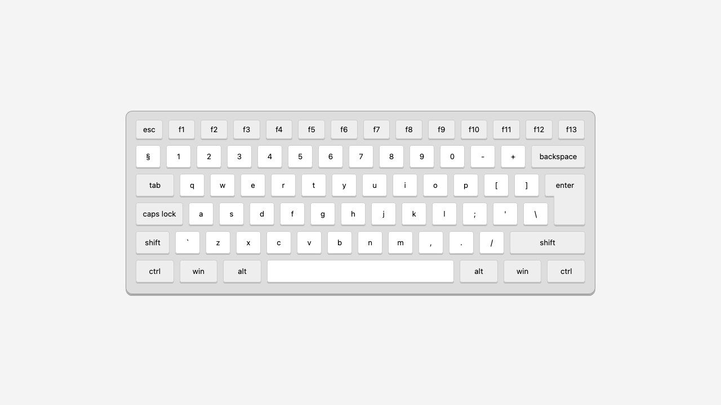

*For full screenshot check the screenshot.png file in the folder for the task*

**Objective:**

Create a webpage that looks like the screenshot above.

**Requirements:**

1. **File Setup**:
   * Create an HTML document named **keyboard.html**
   * Create a CSS file named **keyboard.css**
2. **Flexbox Center**

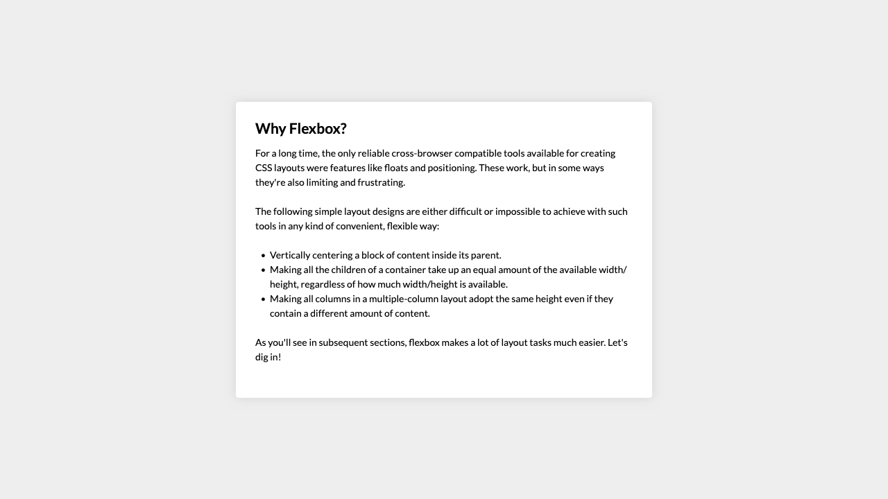

*For full screenshot check the screenshot.png file in the folder for the task*

**Objective:**

Create a webpage that looks like the screenshot above.

**Requirements:**

1. **File Setup**:
   * Create an HTML document named **flexbox-center.html**
   * Create a CSS file named **flexbox-center.css**
2. **Layout Sticky Footer**

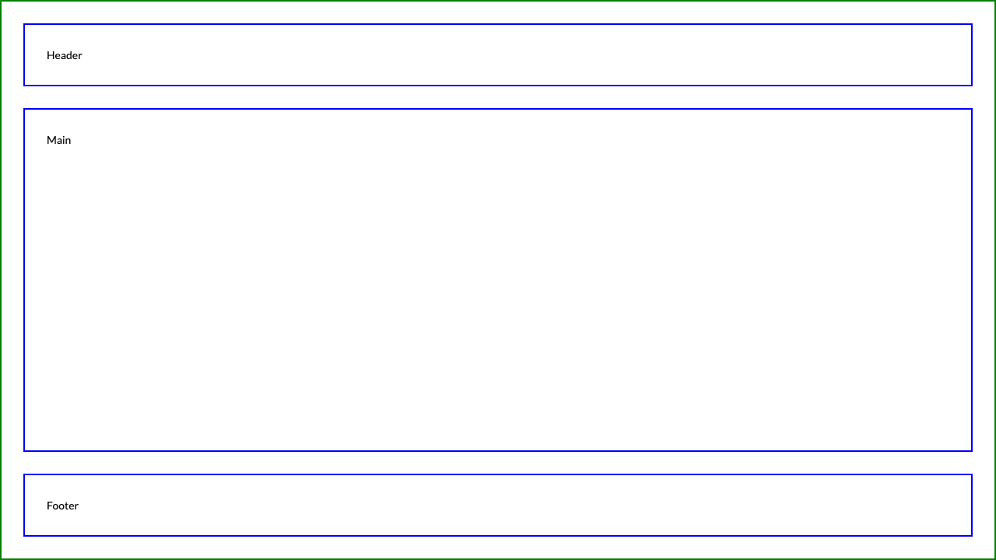

*For full screenshot check the screenshot.png file in the folder for the task*

**Objective:**

Create a webpage that looks like the screenshot above.

**Requirements:**

1. **File Setup**:
   * Create an HTML document named **sticky-footer.html**
   * Create a CSS file named **sticky-footer.css**
2. **Section Banner**

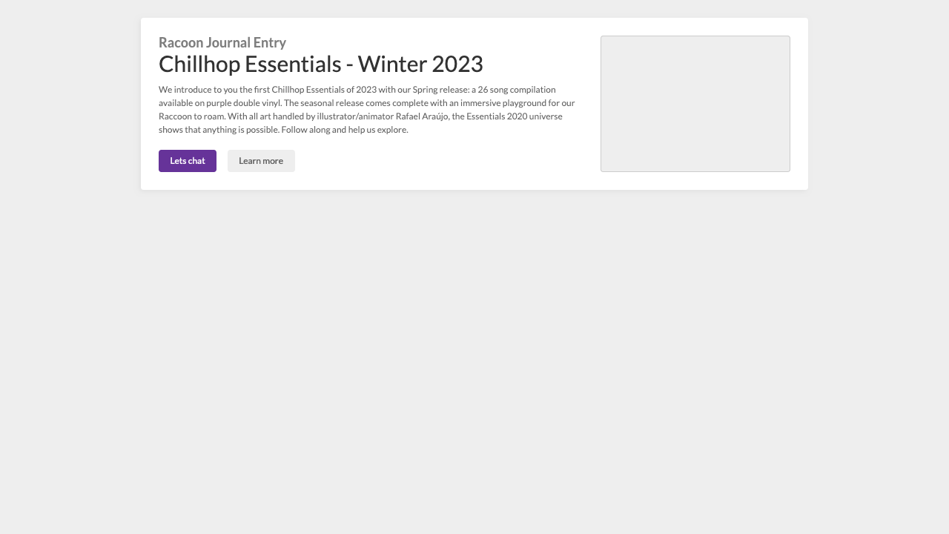

*For full screenshot check the screenshot.png file in the folder for the task*

**Objective:**

Create a webpage that looks like the screenshot above.

**Requirements:**

1. **File Setup**:
   * Create an HTML document named **section-banner.html**
   * Create a CSS file named **section-banner.css**